CS 340 README

About the Project/Project Title
This is a Python module that handles CRUD (Create, Read, Update, Delete) operations for a MongoDB database. It connects to the Austin Animal Center (AAC) outcomes database, which has 10,000 records of animal shelter outcomes. The module is a single class called AnimalShelter that other Python scripts can import to talk to the database without writing their own connection or query code. It was built for Grazioso Salvare, a rescue-animal training company that needs to filter shelter animals to find good search-and-rescue candidates.

Motivation
In a client/server setup, you need something between the user interface and the database. Writing raw MongoDB queries every time you need data gets repetitive fast. This module sits in the middle and gives you four methods: create, read, update, and delete. I built it for CS 340 at SNHU, where the end goal is a full dashboard application. Having the CRUD logic in its own file means I can swap out the front end later without rewriting the database code.

Getting Started
You need a running MongoDB instance with the AAC dataset loaded and an authenticated user account. The setup has two parts: importing the CSV data and creating a database user with the right permissions.

Database Setup
The AAC shelter outcomes CSV was imported into the aac database using the mongoimport tool. The command specifies the database name (aac), collection name (animals), file type (csv), and uses the --headerline flag to treat the first row of the CSV as field names. The --drop flag clears any existing data in the collection before import to avoid duplicates.
mongoimport --db aac --collection animals --type csv --headerline --drop ./aac_shelter_outcomes.csv
The screenshot of this import is shown in the Screenshots section below.

User Authentication
The aacuser account was created in the admin database with a readWrite role scoped to the aac database. This way the account only has the permissions it needs for CRUD operations on the shelter data, nothing more. The screenshot section shows three things: the db.createUser() command, the db.auth() call that verifies the credentials work, and the connectionStatus output that confirms aacuser is logged in with the right role.

Installation
MongoDB (v7.0) is the database server. It stores data in JSON-like documents, which is a good fit for the AAC dataset since the records have a lot of different fields. Python 3 is used for the module itself, and PyMongo is the driver that lets Python talk to MongoDB. I went with PyMongo because it is the officially supported driver from MongoDB and maps pretty directly to the shell commands I already knew (find, insert_one, update_many, delete_many). Jupyter Notebook is used for the testing script since you can run cells one at a time and see the output right away. PyMongo can be installed with pip install pymongo, though it comes pre-installed in the Codio environment.

Usage

Code Example
Import the AnimalShelter class and create an instance with your MongoDB credentials:
from CRUD_Python_Module import AnimalShelter
shelter = AnimalShelter("aacuser", "<password>")

Insert a new document (returns True if successful):
shelter.create({"animal_type": "Dog", "breed": "Labrador", "name": "Buddy", "age_upon_outcome": "2 years"})

Query for documents (returns a list of matching records):
shelter.read({"name": "Buddy"})
Update documents (returns count of modified records):
shelter.update({"name": "Buddy"}, {"name": "UpdatedBuddy", "age_upon_outcome": "3 years"})
Delete documents (returns count of deleted records):
shelter.delete({"name": "UpdatedBuddy"})

Tests
The test script is ProjectOneTestScript.ipynb. It imports the CRUD module, creates an AnimalShelter instance, and runs through all four operations in order. Step 1 imports the module. Step 2 connects with the aacuser credentials. Step 3 inserts a test dog record and gets True back. Step 4 reads it back and gets the full document in a list. Step 5 updates the name and age, and a verification read confirms both fields changed while everything else stayed the same. Step 6 deletes the record and a final read returns an empty list. Open it in Jupyter Lab and run each cell with Shift+Enter.

Screenshots
Below is the mongoimport execution showing the CSV data loaded into MongoDB:
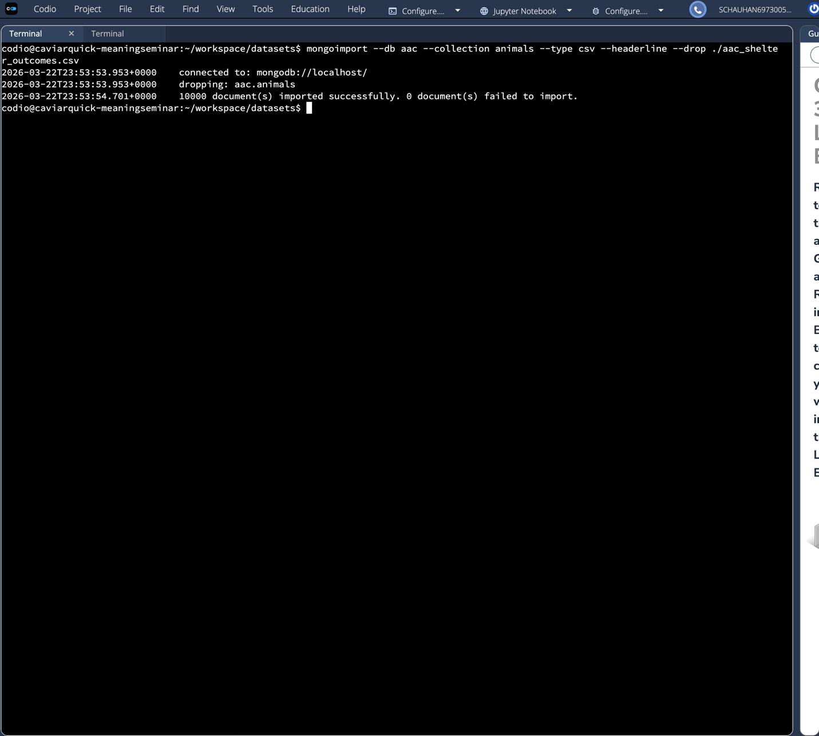

Below is the user authentication setup showing aacuser creation, authentication, and connection status:
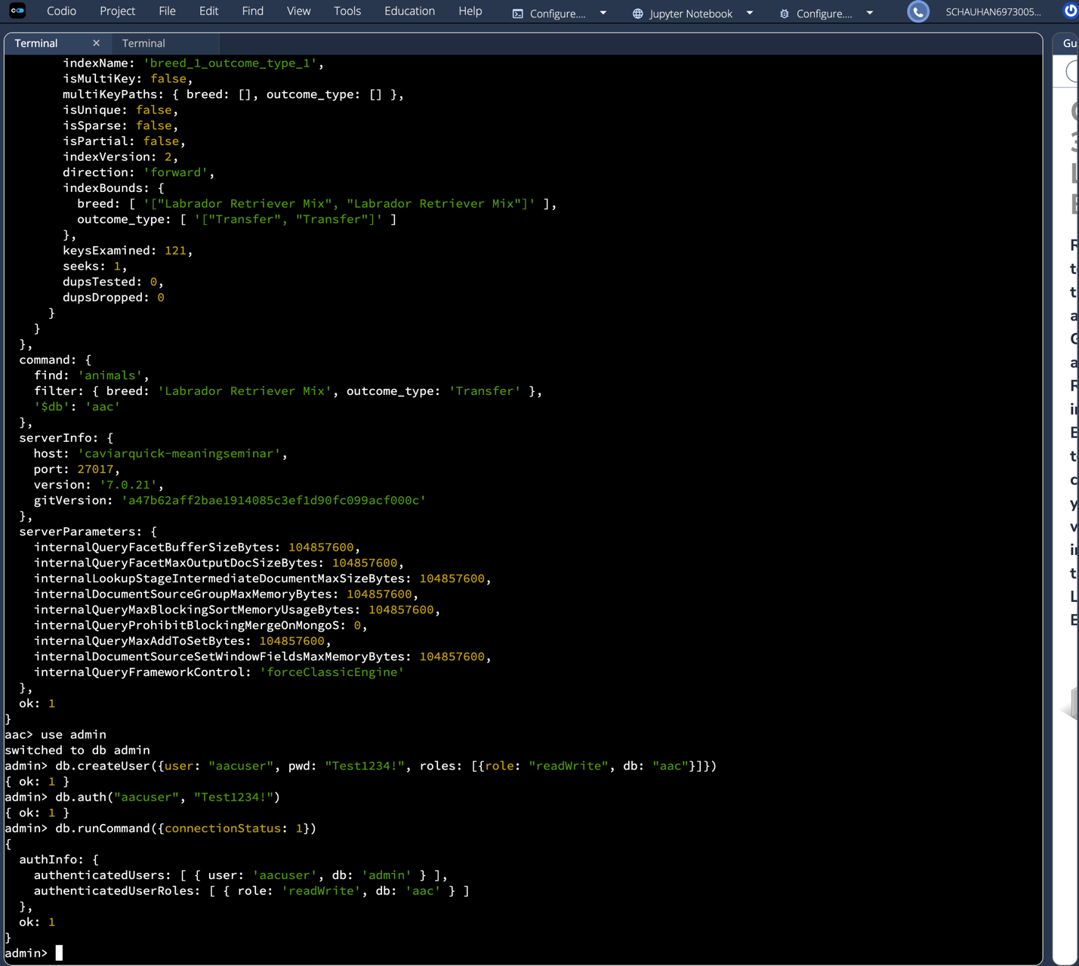

Below is the test script running in Jupyter Lab. Steps 1 through 4 show import, connect, create (returns True), and read (returns the document as a list):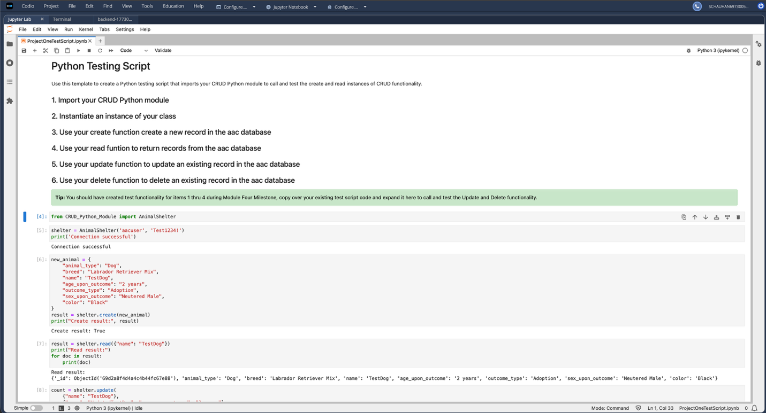

Steps 5 and 6 show update (1 document modified, verification read confirms changes) and delete (1 document deleted, final read returns empty list):
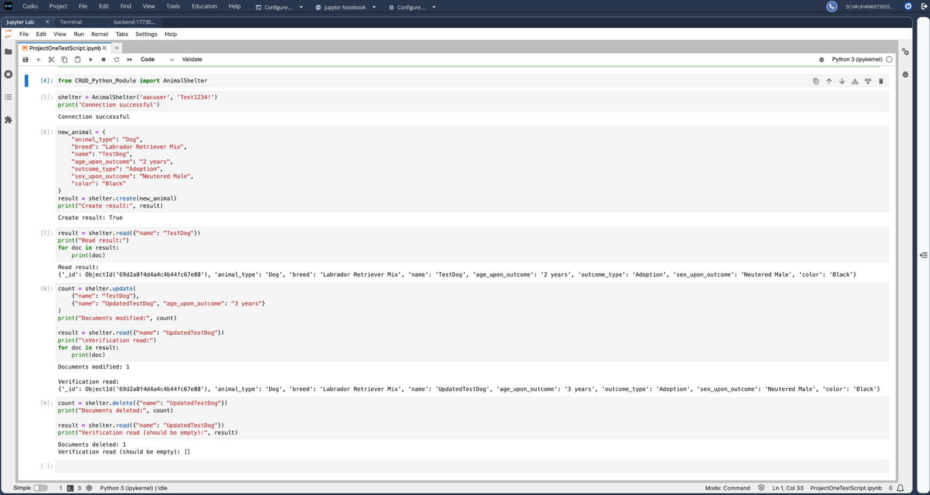

Challenges
One issue I ran into was that the aacuser account had been created in a previous Codio session with a different password, so authentication kept failing with an OperationFailure error. I fixed it by opening the mongo shell, switching to admin with 'use admin', dropping the old user with db.dropUser('aacuser'), and recreating it with the right password using db.createUser(). After that it connected on the first try.

Roadmap
The next phase of this project is building a Dash-based web dashboard that uses this CRUD module to filter shelter animals by rescue type. The dashboard will let Grazioso Salvare staff search for dogs that meet specific training criteria like breed, age, and location. Longer term, adding input validation and logging to the CRUD module would make it more production-ready.

Contact
Sanjay Chauhan

